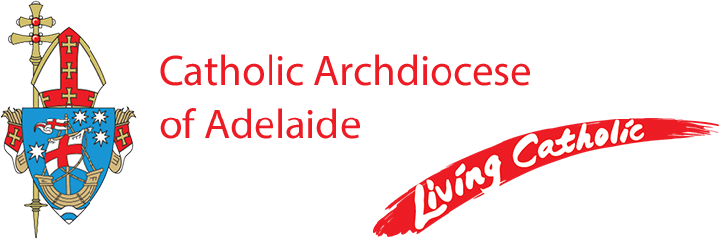

Coordinator, Mary Mackillop Penola Centre

**Part-time, (30 hrs. per week)**

The Adelaide Archdiocese (Mary MacKillop Penola Centre Committee) invites applications for the position of **Coordinator** to manage the day-to-day operations of the Mary MacKillop Penola Centre, located in Penola, South Australia.

This unique role includes oversight of the Mary MacKillop Interpretive Centre, the Woods-MacKillop Schoolhouse, Cameron Home, and associated displays, facilities, and grounds. The coordinator will ensure the smooth running of all Centre activities and services, working closely with volunteers to deliver a high standard of service to visitors while maintaining smooth and efficient operating systems.

**Key responsibilities include:**

* Coordinating volunteer involvement and supporting a positive, collaborative team environment
* Managing group bookings and visitation with a focus on hospitality and professionalism
* Developing and maintaining efficient administrative systems and procedures
* Implementing strategies for continuous improvement across all areas of the Centre
* Overseeing business functions including IT, finance, and property management
* Promoting the Centre’s Josephite culture and values, fostering a welcoming and respectful workplace

The successful candidate will possess excellent interpersonal and leadership skills, with demonstrated experience in business services and operational management. A strong commitment to the Catholic ethos and Josephite charism is essential.

This is a rewarding opportunity for a dedicated professional who is passionate about preserving and sharing the legacy of Saint Mary MacKillop and Fr Julian Tenison Woods.

A copy of the Position Description can be obtained by emailing Stephen Frawley, HR Advisor at [recruitment@adelaide.catholic.org.au](mailto:recruitment@adelaide.catholic.org.au)

Applications and any enquiries should be addressed to

Stephen Frawley, HR Advisor at

[recruitment@adelaide.catholic.org.au](mailto:recruitment@adelaide.catholic.org.au)

**by 5pm on Wednesday 28 May 2025**

Employment with the Catholic Archdiocese of Adelaide is conditional upon a successful Working with Children Clearance and successful reference checks.

The Catholic Archdiocese of Adelaide is an Equal Opportunity Employer and a Child Safe Organisation.